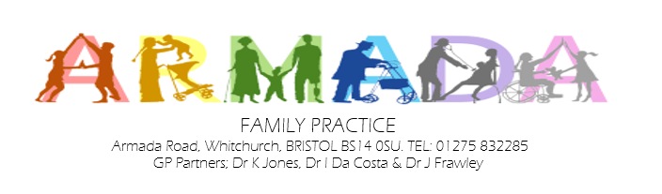



Easy read Privacy

Notice

November 2025

Who are we?

We, at Armada Family Practice our address is Whitchurch health centre, Armada Road, Bristol BS14 0SU are a Data Controller of your information.
This means we are responsible for collecting, storing, and handling your personal and healthcare information when you register with us as a patient.
There may be times where we also process your information.
That means we use your information for a particular purpose, we may also be called a Data Processor.


We are registered with the Information Commissioners Office (ICO) to use information about the people we work with under the Data Protection Act 2018

What information do we collect about you?

Your name


Your address, where you live.

Your phone number



Who is your family, who looks after you.








Your date of birth

What else might we know about you?

Your marital status


Your job if you have one.

Your email address if you have one.


Your religion if you have one.

What you like to be called

Where you were born

How do we keep your information?



Your records are stored on an electronic database system and are protected.

Your records may be stored on paper file, also kept safe.



All staff at the practice must keep your information safe.

Some information we keep about you may be sensitive



Your patient health records are sensitive.


Any safeguards that you have in place to protect you.

Why are we using your information?








To give to other people who are treating you.

To make things better for you at your medical practice.




To share with people organising your care for medical research purpose.

To follow the law, we sometimes need to share your information if...




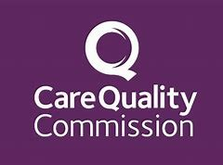

If the police require information as part of a criminal investigation
Information might be required by law due to fraud.

If there is a court order
If the Care Quality Commission CQC require it during an inspection

To comply with the law, we must...



To follow the Data and the Common Law Duty of Confidentiality.

Keep your records safe.
Only authorized members of staff can access your records and are part of caring for you.

Always keep our records confidential and secure.

Why do we share information and under what conditions?


To tell you how personal information will be used.









We need to have a legal reason for using your information without asking you first.

Sometimes your information will be used using your name without your consent.

Who do we share information with?

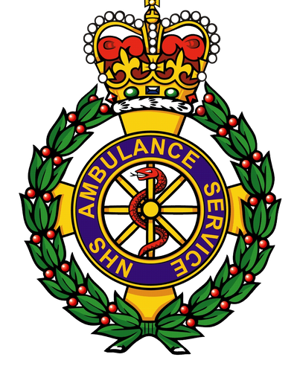

Ambulance Services

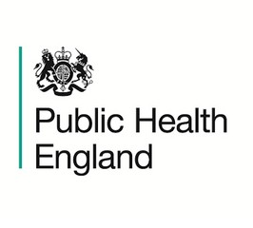

Public Health England and other NHS Trusts



General practitioners
(GPs)

Who else, do we share information with?

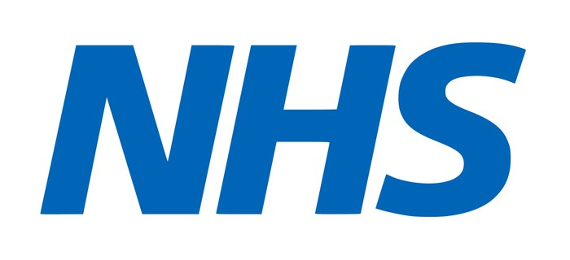

NHS England


Social Services or private care homes to help them give you the best support.




Primary Care Agencies

What does the National data opt- out mean for you?



Information about you is collected when using our services.


Your collected information can be used and provided to other organisations.

Collected information will improve the quality and standards of care provided to you and others.



You have choice whether to use your confidential information to be used.


Use of your confidential patient information about your health and care is only when allowed by law.



Anonymised data is used for research and planning so that you cannot be identified.

If you choose to opt out, your confidential information will only be used to support your care.

What are your rights?
Under UK law The Data Protection Act and GDPR you can...


Tell us not to share your information if you really do not want us to, unless if it is required by law.
Ask us to give you a copy of your records, this is caller a Rights of Access request.
Ask us to change any information if they are wrong or incorrect.
Ask for copies of your documents to other organisations if requested.

If you are unhappy, who do you talk to?

You can speak to our Data Protection Officer:
Lucy Hunt

Email: lucy.hunt11@nhs.net

OR

The information Commissioners Office
Call the helpline on 0303 123 1113

https://ico.org.uk/make-a-complaint/

